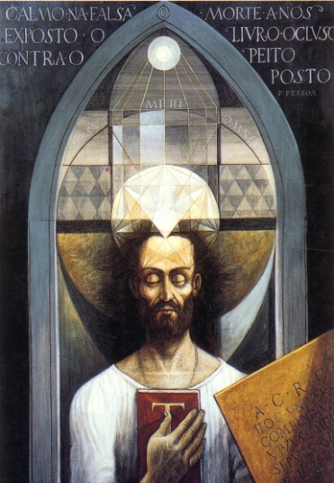
TO DIE AS A ROSYCROSS: A PANACEA ?
By Sébastien GREGOV, Ph. D. candidate, Paris University Sorbonne IV

A paper presented at the CESNUR 2009 Conference, Salt Lake City, Utah
Preliminary version. Please do not quote or reproduce without the consent of the author

“Don't you know that the source of all miseries for man is not death, but the fear of death? ” Epictetus

Introduction

Facing death is not simple for any human being. Legislating for terminal ill patients is even more fraught with emotion. This paper aims to show that a radical change of consciousness brought a reflection on dying with dignity, which has probably to do with varied factors including:
- The pioneering spirit of an obstinate medical advocacy;
- The critical intervention and lobbying of not-for-profit associations;
- And even the support of NRMs, in an either controversial or consensual way.
All these sometimes separate actions led health authorities to modify both their structures and operating processes, and also legislative bodies to pass legislation to endorse these changes.
When some NRMs, by their often advanced – or shifted – position, carried or accompanied this revolution, they were meanwhile forced to come to light publicly, when some rather expected to go unnoticed usually.
From a phenomenological point of view, the process at work is called “monstration” (the act of showing); and to see the same events in a sociological perspective, one can notice a subtle process of “re-mainstreamization”. Both are worth studying here as the two sides of the same coin.

TO SHOW OR NOT TO SHOW, THAT IS THE QUESTION!

I show, therefore I am: the patient’s decree

The complicated choice of visibility
As just stated, the starting point will be the end-of-life advocacy – with its hot debates and complicated stakes –and the phenomenological approach.
Nowadays individuals expect to rule their own death, as they wanted to rule their own life, i.e., freely.
They require the right to die with dignity, even if death without suffering takes precedence over the safeguard of the life at all cost. Therefore, their private interest and their individual vision can fall into conflict with:
- Medical and hospital practices;
- Religious or ethic norms;
- Legislation in force and
- The vision of close relations.
In other words, the Patient’s Decree, (a document that contains anticipated end-of-life provisions that physicians should comply with, if the patient is terminally ill and refuses unreasonable medical obstinacy) points out one’s engagement to the outside world. Any alternative protest prevents one from remaining anonymous.
To what extent will the members of NRMs (who are often exposed to social ostracism and rejection on top of that) make the choice of visibility? And will they try, in that way, to enlist, to persuade and convince? (See chart N°1 making clear the difference between “monstration” and “witnessing”). If we take for instance the case of the Golden Rosycross, a contemporary Gnostic NRM numbering today about 18,000 members worldwide (Breakout by continents: see diagram N°1), we see clearly that this choice can fall into conflict with the teaching itself. According to the Fama Fraternitatis (the Call of the Brotherhood, 1614) the ancient brothers of the first (mythical) Rosycross Brotherhood had to obey six fundamental rules, called the “sixfold agreement” (see chart N°2). Second rule is as follows: “None is to be forced by the brotherhood to wear certain clothes but should follow the habits of the country.” That is to say that invisibility is a kind of strategy performed by the eldest brothers which has to be imitated by followers in order to avoid risky situations where the Brotherhood could not be kept secret.

The power of conviction depends on the transparency of advocacy
The corollary problem directly involved in the previous one is to be solved by the analysis of the speech: To what extent did the discursive productions of the “activists” arise with common designs and registers of scientific neutrality, which would thus reinforce their power of conviction (e.g. experience of “déjà vu”, when one can think “there is nothing new”)? Or on the contrary, in what manner does the speech (and the related body posture: passive resistance, vindication, threat, complex of victimization…) enhance the effectiveness of the monstration (e.g. experience of “jamais vu” – never before seen)?
Lastly, the third component of the demonstration, the starting postulate indeed, supposes a visual relation to the world. The activity of displaying has become a sensitive battlefield, in diversified arenas: at the hospital, in the medical community, even with the judge, close relatives, or followers of the same movement…
Hence the present study seeks to classify:
- The methods by which discussed practices or groups succeed (or not) in drawing the attention of all,
- And the ways in which their discourses succeed (or not) in obtaining the dignity of stable consolidated categories, (e.g. administrative practices, laws, wills, disciplinary, social recognition…)

End-of-life advocacy and its diversified arenas

A historical overview of palliative and end-of-life health care
Palliative care is something relatively new. It hardly existed at all until the early 1970s. The pioneer was Saint Christopher Hospice in London, created by Cicely Saunders in 1967, emblematic for modern palliative care. It involved mainly Catholic physicians. Then the experiment was continued in Canada, by the creation of the first unit of palliative care within a hospital in the world – in Montreal in 1975 (Royal Victoria Hospital). Palliative care appeared suddenly as an innovative field of experimentation. Furthermore, new therapies were born such as analgesic medication and morphine. An alternative to suffering was born.
But why was the fact that one is willing to die so difficult to admit? The reason is that these incurable patients drew attention to the dramatic failure of the whole medical and hospital system. In fact palliative care went completely against the mainline: i.e. against the threefold logic of science, research, and technology prevailing in health care policies and practices. Medical authorities are all firstly and strictly committed to protecting life. Even the Hippocratic Oath condemns euthanasia.
At the beginning any sort of end-of-life health care was assimilated to a deviance; because of the lack of a legislative framework, letting a terminally ill patient die was considered a crime, a homicide and as such, should be punished by law. In most cases, death occurred through neglecting patient’s care. Only the hospital staff could decide “in the last resort” to passively put an end to the patients’ life (clandestine euthanasia) but not the patient himself at all. He was not involved in the decision.
The question of euthanasia arose in the political debate in France from 1984 until 2002. In 2002 the French legal experts were asked “How to meet the expectations of our society in medical affairs?” They gave the following answer: it would be preferable to adjust to the existing law arsenal instead of passing a specific law. Thus, the Leonetti report from March, 4th, relating to patient’s rights and quality of health care acknowledges a patient’s right to terminal care but at the same time to refuse a treatment – in the same way, according to Article 37 of the code of medical practice, the physician should not use intensive medication to keep anyone alive with unreasonable obstinacy, but administer treatment for pain relief, complying with the patient’s and his family’s will.
Because the 1905 Laity Act on secularism needed some contemporary adjustments, two laws were promulgated: the Castex decree 2004 (a government notice addressed to the hospital CEOs) and the Leonetti law, 2005, together with one more decree in 2006.
What are the major issues? Three of them are to be underlined.
- Everybody should be well informed of his or her health condition (diseases, treatments and risks);
- The physician should comply with the patient’s will if he or she decides to stop a treatment; If the patient himself is unable to express his will, a trustworthy person (appointed by him) will do it for him. The ultimate decision is based on two keywords: collegiality and transparency;
- All the anticipated end-of-life conditions, contained in a patient’s decree, are to be signed, (and regularly re-signed), and given by the patient (or the trustworthy person) to the medical authority.

NO MAN IS A PROPHET IN HIS OWN COUNTRY: DIFFICULTIES IN HEALTH CARE ADVOCACY

ADMD and the debate on euthanasia
Of course euthanasia is still a controversial topic. But first of all the controversy bypassed the medical arena and spread into public debates. Who were the first actors of such a tremendous change?

Murderer in his own country, savior abroad
The ADMD (Association pour le Droit de Mourir dans la Dignité/ Association for the right to die with Dignity) has become a major actor of change in France. The website states that ADMD advocates in favor of an end-of-life in accordance with one’s own conception of dignity and liberty. That is why ADMD wants euthanasia to be legalized in France (see chart N°3 with various legislation worldwide), believing that France should fall in with Belgium and the Netherlands for instance. As of June 2009, ADMD has 4,7201 members, most of whom were recruited on the Internet or at places, where the association had a stall and petitioned or proposed hand-outs. According to a survey, 86% of French people are said to be in favor of a law authorizing euthanasia.

Fighting for a “Biological Testament”
It is interesting that the ADMD faces exactly the same problems with policy authorities as NRMs: a mayor for instance did not want the ADMD to have a stall in his market place, others refused to put ads in the local newspaper, etc. In a word, this non-profit-making association which has nothing to do with religion or even spirituality faces somehow the same difficulties as NRMs did in France for about 15 years. In certain countries a “Biological Testament” is to be acknowledged – the achieved form of “patient’s decree”?
Furthermore the ADMD is connected to a wide network operating in the whole of Europe, especially in Switzerland (Exit and Dignitas), where this public networking advocates assisted suicide. To sum up, we saw that these organizations could take the place of the hospital, on the one hand, (like in a hospital in Lausanne (CHUV)), or the place of the Church, on the other hand, as Exit or Dignitas reinvents a ritual for death. Soon the so-called “Doctor Death” will not be doctors anymore! Due to public advocacy and pressure groups, the legislative power is going to oblige medical practitioners to let voluntarily dying people leave hospital, and relatives let them die as they want to. And this time, if the discourse uses nearly the same words, it goes much further, it sounds more radical.

In the name of blood: the Jehovah’s Witnesses’ controversy
Jehovah‘s Witnesses used to be the topic of some controversial conversations by refusing blood transfusion (but not transfusion of the individual’s own blood nor organ transplantation). According to their beliefs, the one who receives blood from a third party becomes unclean and consequently he can be expelled from his Church. The Jehovah’s Witnesses saved by medicine are then lost for eternal salvation.

From self-defense to persuasion… and promotion
They had to face sharp critics and disfavors, because they were blamed for refusing any health care and letting themselves die, by virtue of a divine will… So they had to clarify their purpose in order to clear themselves. For public authorities they added on their (French) website a tab leading to a FAQ file about the “sacred nature of blood”. It consists in the solemn declaration of the Jehovah’s Witnesses’ National Consistory of July, 3, 2007 (to download as a PDF-document).
It is therein stipulated that they systematically use health care, in accordance with biblical principles (life is sacred), and hold themselves aloof from miracle cure. Blood saving is seen as an alternative to blood transfusion and especially supported in case of surgical operation. In 1996 practitioners began to recognize their efforts in developing this operating process. Professor Jacques Belghiti, head of department for digestive surgery in Clichy (France), says: “This challenge urged us on to develop early a more and more elaborate technology (…) and unexpectedly a deliberately non scientific position coincided to scientific discoveries upon the dangers of transfusion.” Moreover the Jehovah’s Witnesses built up an international mediation and information center, which led to an agreement to heal Jehovah’s Witnesses according to their beliefs.

Re-mainstreamization with scientific effectiveness
In other words they now can use their official website to explain why they do act as they do; this means enabled them to work together with physicians, to come to an agreement with practitioners (conciliation) and at least it gave them the opportunity for promoting their conception of life care. Moreover, they really support the medical research by acting voluntarily in human experiments (like open heart surgery without blood transfusion!), assisting scientific research, and supplying new medical surgical services and so, they give the demonstration that surgery without transfusion is possible. Faster than any other scientific staff could have done… and using the same discourse!

THE ENDURA: THE GOLDEN ROSYCROSS FACING THE MYSTERY OF DEATH

Now we shall focus on the case of the Golden Rosycross – to be exhaustive the “International School of the Golden Rosycross”, also called “Lectorium Rosicrucianum”. The L.R was founded from a schism in 1924 between its founders, three Dutch esotericists (whose names are: Jan Van Rijckenborgh, Catharose de Petri and W.Z. Leene) and the Max Heindel Rosicrucian Fellowship.
The former rather refer to the Gnostic thought while the latter prefers the occult rosicrucianism. So both are dealing with the underlying myth of Christian Rosycross who supposedly lived in the 15th century (1378-1459), but the meanings are different, especially about the meaning of death. The L.R. shares the view of Max Heindel as far as the “mechanical” dying process is concerned, but differs on many points about the afterlife learning situation and the benefit for man. To say it clearly, the dying process appears as an empty walnut shell in Van Rijckenborgh eyes, if it is not innerved by a higher overwhelming dimension: I-lessness. And to put it shortly from the beginning: the L.R. is against euthanasia but advocates a “patient’s decree”. Why is that so?

Death seen in Heindel’s light: to die is an opportunity to learn, and through hardships, to become more mature

Heindel dealt much with death and after-death life of the different bodies constituting the human being: 4 bodies are to be found: the physical body, the etheric or vital body, the astral body and the mental body. For Heindel Death is the end of the homeostasis, the constant balance, between the 4 bodies (see chart N°4).

The purgatory and the three heavens
The dying process occurs according to Heindel as follows: the 2 former bodies – physical and etheric – separate from the 2 latter in a spiral movement, and each permits the dead person to live again his past life, but in a distinct manner, in a reverse order, and not simultaneously with each one. Firstly “man stands as a spectator before this panorama of his past life. He sees the pictures as they pass and they impress themselves upon his higher vehicles, but he has no feeling about them at time. That is reserved until the time when he enters the Desire World, which is the world of feeling and emotion.” (The Rosicrucian Cosmo-Conception, p. 102) The duration of each journey through each of the ether quality depends on the way the dying man is bound to the Desire World: “As long as man entertains the desires connected with earth life he must stay in his desire body and as the progress of the individual requires that he passes on to higher Regions, the existence in the Desire World must necessarily become purgative, tending to purify him from his binding desires” (The Rosicrucian Cosmo-Conception, p. 104). That is why Heindel speaks of “purgatory”, preceding the three next stages or “heavens”. The idea underlying Heindel’s conception is that the experiences will be forgotten in succeeding lives, but the feeling remains: “It is the “still, small voice” which warns us, though we do not know why; but the clearer and more definite the panoramas of past lives have been, the oftener, stronger and clearer shall we hear this voice.”(ibid., p. 109) Here appears clearly the pedagogical meaning of death for the Rosicrucian Fellowship: “Thus we see how important it is that we leave the passing spirit in absolute quietness after death. By so doing we help it to reap the greatest possible benefit from the life just ended and to avoid perpetuating the same mistakes in future lives (…). The mission of purgatory is to eradicate the injurious habits by making their gratification impossible. (ibid., p. 110)” As a consequence “the individual suffers exactly as he has made other suffer (…) Because of this suffering he learns to act kindly, honestly, and with forbearance toward others in the future. (…) When he is reborn he is free from evil habits, at least every evil act committed is one of free will.”
That is why the dead corpse should be maintained in a calm atmosphere – mostly without the crying and vociferating relatives! – to enjoy this panorama of a life like on a wide-screen interactive TV-program.
For Heindel, the deal is that the dead person becomes conscious of what he or she did right or wrong and how he or she lets others suffer.
Within the 3,5 days after death, the physical impressions are still close, and the sensitive ones too. A lying corpse in a calm (refrigerated!) room makes therefore the memory work easier. After this duration, other experiences are available, which could take much more time (particularly long for materialistic people for instance). The cremation can be there an aid to go forth more quickly (but is to be avoided in the first three days after death, according to Heindel, because it tends to disintegrate the vital body, which should be kept intact until the panorama of the past life has been etched into the desire body (see The Rosicrucian Cosmo-Conception, p. 98).

The three theories on death
Summarizing the whole, Heindel opposes three current theories on death. “The materialistic theory holds that life is a journey from the womb to the tomb; that is the result of certain correlations of matter; that man is probably the highest intelligence in the Cosmos, and that his intelligence perishes when the body disintegrates at death. The theory of Theology asserts that at each birth a newly-created soul enters the arena of life fresh from the hand of god, passing from an invisible state through the gate of birth into visible existence; that at the end of one short span of life in the material world it passes out through the gate of death into the invisible beyond, whence it returns no more; that is happiness or misery there determined for all eternity by its actions during the infinitesimal period intervening between birth and death. The theory of Rebirth teaches that each soul is an integral part of God, enfolding all divine possibilities as the seed enfolds the plant; that by means of repeated existences in an earthly body of gradually improving quality, the latent possibilities are slowly developed into dynamic powers; that none are lost by this process, but that all mankind will ultimately attain the goal of perfection and reunion with God.” (The Rosicrucian Cosmo-Conception, p. 148) He sees the first theory as monistic, both the second and third as dualistic, that is, they ascribe some of the facts and phases of existence to a super-physical, invisible state, but they differ widely on other points. For Heindel the law of Rebirth, coupled with the companion law of Consequence, is the only theory that can satisfy a sense of harmony and justice.

The difference between The Rosicrucian Fellowship and the Lectorium Rosicrucianum: the Gnostic component
Here is the moment to stress the difference between Max Heindel and Jan Van Rijckenborgh because it explains why the L.R. does not deal so much with death, but rather drives the teaching towards a new attitude of life. For Heindel, man is able to become perfect by learning endlessly (principle of automatic evolution), that is why death is as important as life, because the dead reaps then all he sowed before in his life: “So man builds and sows until the moment of death arrives. Then the seed time and the periods of growth and ripening are past. The harvest time has come, when the skeleton specter of Death arrives with his scythe and hourglass” (The Rosicrucian Cosmo-Conception, p. 96)
For Jan Van Rijckenborgh, on the contrary, the time after death should be as short as possible, so that the person could as soon as possible have the opportunity to become incarnated again till the incarnation process becomes useless, and he or she can reach the realm of salvation. But before entering the eternity, the old I must be sacrificed and a new I is to be born. This self-willed process (but at the same time occurring without the intervention of the ordinary will! This is the whole paradox of self-sacrifice in a Gnostic way) is called in the Spiritual School “endura” or change of being of the personality. The result of the process is therefore called “transfiguration”.
So, the Gnostic thought is predominant, that is the teaching of the two orders of nature: the I-personality is not the whole man, rather something like an image-bearer of deity. The whole real man is seen as a microcosm, a little world and a perfect light garment embodying love and truth. What is commonly meant by “man” is but the maimed personality of a degenerated microcosm. As a result, our present consciousness is a personality-consciousness and is only conscious of the field of existence to which it belongs: dialectics.
As long as the I-personality does not make room for the eternity in him, trapped in his heart (this is the rosebud in the Rosycross symbolic!), man is condemned to death, and another incarnation is necessary to offer the „Other in me“ a new chance.
In other words – and to make it clear once more – Jan Van Rijckenborgh does not believe that the I-man is perfectible, neither during life nor after death.

The endura or dying daily: nothing in common with suicide!
The L.R. has to face polemics which is completely unknown for the Rosicrucian Fellowship. To claim to belong to the Gnostic community means to bear its heritage too, but that means, with regard to death, to take on board an old heretical teaching.
For two main reasons, the L.R.’s teaching had to emphasize clearly from the beginning why and how it was indebted to ancient Gnostic wisdom. It faced indeed two reproaches: Gnostics were blamed for having an anti-natural way of life; they were supposed to deny life any significance and even to incite suicide. Catharose de Petri in Transfiguration (Chapter 1, p.11) means on the contrary that “the path of the endura by transfiguration is the only natural, logical path, the only one that deserves and is able to remove the curse hanging over our being and give an adequate solution to the problem of mankind”. Jan van Rijckenborgh writes very similarly about suicide by Gnostics to clear them: “That is why we discuss this with you; that is why we meet this activity in an extremely sensitive way, by giving timely explanations concerning the correct intentions of the Gnosis. The man who stands in the Light-birth of God [within him] and has decided upon the “endura” [this word will be explained later], is not the one who inevitably puts an end to his life, not the one who in a criminal sense would kill himself, but a man who in an intelligent and scientific manner co-operates with the process of becoming a new man, which starts with the birth of the Light. Such a man will maintain his old being for as long as it is possible for the sake of serving mankind, even though this old being has died through transfiguration.” And further down, he insists: “Just remember, the first condition of the path of liberation is: self-sacrifice in the service of mankind. All progress on the path of the Gnosis depends on the service of mankind through negation of the self. That is why the transfiguristic candidate will maintain the old being as long as possible, to the last gasp, in order to continue to serve endangered mankind. We cannot be clearer than that!” (The Gnosis in present-day manifestation, part V, chapter IV, pp. 238-246)

“I have, while living, made this temple into a grave”
Now using on a commonly accepted terminology, the esotericist explains what the Cathars called endura, and was indicated, according to the author, by Gnostics as self-renunciation, to prevent one more time any misunderstanding. Defining the achievement of self-sacrifice, he writes: “The old soul, the nucleus of your personal existence, has indeed passed away. As soon as the breakthrough of the Light can be celebrated, the old soul has disappeared and a new soul has been born in the old state of being. Now the rebirth through the Holy Spirit begins. That necessarily entails a further destruction of the still existing old being of nature. The new soul has been born, but in the old dialectical being. That is why the remainder of the old being must be liquidated. Accordingly, an entire new being must grow, a totally new personality, in which the reborn soul can live harmoniously and in which it will truly be enabled to express itself.” And to add a last remark, now that Van Rijckenborgh has explained the mechanical principle, namely that the new soul grows in direct inverse ratio, he points out the joy related to self-renunciation, which is not so obvious! “So you, who imagine that you have already entered the Light-birth and experience your new soul-state, are naturally whole-heartedly prepared to give up your old existence, as you experience that its existence hinders you in many respects. That is why you no longer have the slightest desire to hold onto your old bodily structure with all kinds of expedients, food and medicines. That would be simply ridiculous. On the contrary, you are whole-heartedly prepared and also in a position to co-operate with the dissolution of your old bodily structure. You do this very consciously, very intelligently and with great joy.”
As a result, the new soul, born from the will of God, but not that of man, Jan Van Rijckenborgh goes on, is hermaphroditic in nature. It is self-creative. “If you now think back of what we mentioned previously, you will see that, as soon as the fundamental radiation of the Gnosis can be assimilated, a division with seven aspects develops: the healing Seven-Spirit manifests itself in our soul-state. A very powerful light emanates from the new soul, a radiant fire comparable to the fiery tail of a comet. The seven aspects, the seven new chakras of the new vital body can be clearly seen in this ray of fire. The new soul can be totally self-creative for it creates a structure of force lines, in which the fire-column with its seven aspects is central. Thus, we see how a new vital body arises out of the new soul, which results in the manifestation of a new material body, not born of nature, delicate and of a very noble form. As soon as this building is complete (this development takes place rather quickly), the old being can be laid aside and carried tot the grave, if so desired. For the new being has risen in the self-made tomb. Thus the reborn one stands as the resurrected one in the self-made tomb, not only by virtue of his soul-state, but also by virtue of his personality. He can joyously testify as C.R.C: “I have, while living, made this temple into a grave”. The wonder of the entrance into the nature of God is realized through the self-disintegration with regard to the nature of death.”

The fivefold Gnosis: passing the “golden death” while living
Now we are better able to understand and interpret the position of the L.R. regarding death.
The first agreement in the Fama Fraternitatis (see chart N°2) gives its general framework: “None is to exercise another occupation than to heal patients, and that for free”; healing for free is the main duty of the Golden Rosycross; but that means firstly that the pupil recognizes how ill he is (“insight”), that he yearns for healing (“craving for salvation”), that he is ready to purify his being by dying daily (“self-surrender of the I”); the mystic “golden death” then takes place while living, and leads to a “new attitude of life”. To sum up the whole, the endura (or transfiguration) is reached as a highlight after passing these four stages and means eternal life of the soul within the mortal shape of the I-man, possibly before he eventually dies. For Gnostics from the L.R., daily dying is the only way to defeat death.
If we remember the phenomenological approach we intended to have –we wanted to state if this esoteric discourse is strategically viable – we should conclude that the fivefold Gnosis as described above is not necessarily understood by the mainstream. The terminology is based on the use of most unknown words or notions one can only understand if he follows a detailed presentation of the teaching. The L.R. offers an introduction to the Gnostic teaching in the form of more or less 12 weekly lessons, i.e., despite its somehow rational, even scientific scope, the teaching could seem odd. Its rationality and logic is connected with presuppositions modern science does mostly not deal with (e.g. the ether theory). So, one can draw the conclusion that this kind of discourse may not succeed in obtaining the dignity of consolidated category. And even if what we have discussed so far is easily available in every library! The next point will focus on the practices and rites as they are commonly celebrated in the Lectorium Rosicrucianum.

The whole range of spiritual tools: how to die in the L.R.
It is time to underline how private the dying process should remain for everyone. And that goes in the L.R. too. The patient’s decree (in accordance to the law in such and such country – remember chart N°3) is to be recopied in one’s own hand by each pupil according to his own wishes: everyone should feel free to accept some points and leave others out (see chart N°5). The same goes for the Testament (see chart N°6) written in one’s own hand too. Another daily practice is sometimes mentioned in the teaching of the Spiritual School: the end-of-day introspection.

Reviewing the day’s happening as a kind of methodical death training
Pythagoras’ golden verses are a book that is often recommended in the L.R.. They were life rules by Pythagoreans dedicated to prepare a permanent state of meditation:
“40. Never suffer sleep to close thy eyelids, after thy going to bed,
41. Till thou hast examined by thy reason all thy actions of the day.
42. Wherein have I done amiss? What have I done? What have I omitted that I ought to have done?
43. If in this examination thou find that thou hast done amiss, reprimand thyself severely for it;
44. And if thou hast done any good, rejoice.
45. Practice thoroughly all these things; meditate on them well; thou oughtest to love them with all thy heart.
46. ‘Tis they that will put thee in the way of divine virtue.”
Verses 40 to 50, which conclude the purification process of Pythagoreans, praise the introspection at the end of each day: the fact of reviewing the whole past day upside down, and considering good as well as bad deeds. It reminds one of the words of Max Heindel in the Cosmo-Conception (ibid., p. 111): “In reviewing the day’s happenings and blaming ourselves for wrong, we should not forget to impersonally approve of the good we have done and determine to do still better. In this way we enhance the good by approval as much as we abjure the evil by blame.” “Repentance and reform are also powerful factors in shortening the purgatorial existence, for nature never wastes effort in useless processes,” Max Heindel also states in his book. But this is always the same in the L.R.: this exercise may be recommended, no one is obliged to do it. Nevertheless one can consider that practice as daily death training. In Heindel’s eyes, the end-of-day introspection is very similar to the end-of-life repetition of past life, and could even shorten significantly the purgatory experience.
But there are rituals too which apply to all members of the Lectorium Rosicrucianum. Members act then as a group and not personally.

The healing services
The so-called “healing services” are one of the means used by the Rosicrucian movement “to preach and heal” as Christ said; the healing service is understood as a place and a moment, where magical help is given to mankind, in a totally impersonal way, especially to stand by ill pupils of the Lectorium Rosicrucianum on the one hand, but also to intensify the Gnostic radiation upon the world, on the other hand. Gnostic light force (the biblical “manna”) is then converted into a food easily assimilated by mankind, irrespective of race or religion. This service takes place weekly in every town center and conference center and is the task of the pupils of the 3rd, 4th and 5th grades in the Spiritual School (see chart N°7). These three grades are really the heart of the Lectorium Rosicrucianum. They take a central position, considering firstly the number of members: the highest amount of pupils participates in one of these grades and the “inner school” – the esoteric body of the whole pyramid – properly begins with the third grade. Secondly the two previous grades build the “outer school” or threshold, while the two next grades are mostly described as immaterial. On the diagram N°1 showing the evolution of work fields in given countries (going from the youngest to the eldest working fields), one can see the growing extent of these three medium grades through ages.
The weekly meetings are interrupted twice a year in winter (January-February) and summer (July-august), but sustained by a monthly letter which the pupils who expressly ask for it receive all year long. They are supposed to write in their turns, and by their own hand, a letter once a month to make sure they are still bound to the healing and protecting process and are still contributing to it in return.

The Service of Detachment and the Vacuum of Shamballah
When someone in the Spiritual School dies a special service is given in the Temple where he or she used to go within the three days following the death. The pupils gathered there concentrate their attention to a column of fire which should guide the dead person through the so-called “reflection sphere” to a secure (non material) place known as “Shamballah” (see diagram N°3). In all glossaries (at the end of the main books of Jan Van Rijckenborgh) you can find the following definition: “The vacuum of Shamballah denotes a region situated outside the material sphere and the reflection-sphere (…) on behalf of those pupils who, seriously, devotedly and tenaciously have strived after the Path of return, but who could not yet enter the New Field of Life [when death occurs]. In this specially prepared working-sphere, in most harmonious circumstances, free from the difficulties, impediments, dangers and vexations of dialectics such pupils are offered an opportunity of completing – if only there is a minimum working-basis for the continuation of the work that has been started – their liberation from the wheel and of participating in the New Life” (see The Coming New Man, by J. V. Rijckenborgh, p. 366). A lacking definition should be mentioned too in order to understand fully the previous quote: the one of material sphere/reflection-sphere: “The two spheres of existence in this dialectic nature-order. The material sphere is the region in which we live in our material figure. The reflection-sphere is the region in which, among other things, the process between death and reincarnation is enacted. Besides the spheres of hell and the so-called purgatory (the purification sphere), it consists of what is wrongly called ‘heaven’ and ‘eternal life’ in natural religion and occultism. These heavenly spheres and the existence therein are just as much subject to finiteness and temporariness as is the entire existence in the material sphere. Therefore the reflection-sphere is the temporary abode of the dead, but this does not mean that the deceased personality will come to life anew: for there is no survival of the fourfold personality! Only the deepest nucleus of the consciousness, the so-called spirit-spark-atom, is temporarily withdrawn into the aural being and forms the basis of the consciousness of the brand-new personality which, in conjunction with forces working in the mother, is constructed by the aural being.” (ibid., p. 363)

EPILOG: THE GOLDEN ROSYCROSS BETWEEN MARGINALIZATION AND RE-MAINSTREAMIZATION
Now drawing to a close, one can clearly see why the esoteric speech of the Lectorium Rosicrucianum has not been configured yet for being established and recognized as a stable category by many people. In the last quote the difference is underlined between the mainstream churches (“natural religion”) or even other marginalized (but in the same time mainstreaming new religious) movements (here falling into a ragbag of a category: “natural occultism”) AND the Lectorium Rosicrucianum. Inside the movement itself the members keep marginalizing (making a difference between sympathizers and core members (“outer School” versus “inner School”); and they stress the filiations but also the differences between the mother-teaching (Heindel’s Cosmo-conception) which is marginalized and the mainstream (Jan Van Rijckenborgh’s teaching of dialectics and two nature-orders). One can see how relative and fluctuating these categories can be. The need of a specific language and the glossary at the end of books of the School is also a sign of deliberate self-marginalization.
But at the same time the International School of the Golden Rosycross faces with a deep internal transformation going forward more or less faster in the different countries, depending on how the mainstream considers new religions. In the Netherlands (the Headquarter of the school is located in Haarlem), the L.R. has already been recognized as religion (By the way, the Netherlands are one of the first countries, along with Belgium and Switzerland, where euthanasia has been legalized). In many other countries, the “re-mainstreamization” takes time and can backtrack at any time.
The reason why things are going to change so drastically in France too has maybe something to do with the new president Nicolas Sarkozy and his particular and own way to deal with religion. Since he was elected in 2004 he has taken rather controversial positions in the land of secularism. A heated argument ensued after his two policy statements in 2008 in Rome and Riyadh for the attention of representatives of religions. He gave secularism a new meaning and introduced the term of “open secularism”. “I know that many accuse me of being too much interested in religion, but I think those can be respected who want to go to church and open libraries on Sundays”, he stated, “this is absolutely not contradictory. I did not put secularism badly into question.” In Riyadh on January, 14, 2008 he repeated 13 times the word “God”, and pointed out that in each civilization there is a religious nucleus.” Today, he said, not the religious feeling is dangerous, but its use for political reasons, towards regression and new Barbary.” Although he is governing a country which is based on the separation between Church and State, he says, he respects those who believe in heaven as well as those who do not. “This is my duty to make it possible for everyone, if Jewish, Catholic, Protestant, Muslim, atheist, freemason or rationalist, to feel happy to live in France, to feel free, to feel respected in one’s beliefs, values, and origins. But this is my duty too to preserve the heritage of a long history, a culture, and I even dare say: a civilization.” These considerations fully explain the evolution of the relations between the State and Religion in France, and the Leonetti law is the perfect proof that a new course is being steered, that of greater respect and acknowledgement.

Conclusion:
Since the mid 1990s, the Rosicrucians of the Golden Rosycross have leant towards either marginalization or re-mainstreamization. The first time, in 1996, when the government led an anti-cult campaign, they had to fight for their survival; in 2005, with the successful end-of-life advocacy, they were suddenly on the side of the State and benefiting from its protection. If the activist associative networks and certain categories of health practitioners had the public policy improved and thereby the society, it is now up to New Religious Movements, as civic pressure groups, to comply: how will they use this lately acquired freedom?
It is virtually certain that the decisive advance in this so tender spot (ageing and dying frightens nearly all of us) can be explained by the in-depth analysis that the members carry out, during their pupilship, about the question of death and which leads them to forsake the life “with lower costs”, when for instance its maintenance does not make sense anymore: “To Study philosophy is to Learn to die,” says Michel De Montaigne quoting Cicero, in its "Essays" (Book I, chapter XIX )…
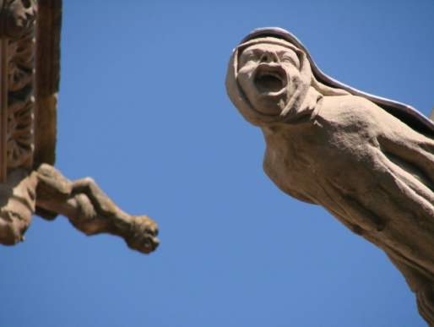

ANNEX

Chart N°1
MONSTRATION VERSUS WITNESSING

ACT OF SHOWING | MONSTRATION | WITNESSING
People involved | Media, public opinion, activists | NRMs, members ‘s close relations, doctors, eventually public opinion
Field of action | Sensational attraction;  visual politics | Primarily : Intimate, private sphere
Kind of visibility | Reinforced, wanted visibility | Forced, constrained visibility
Short-term Results | Gives the opportunity to display or even to flaunt (with proud) a specificity | In due course obliges the members to display and claim their belonging to the movement and break the silence
First Consequences | At last freed from anonymity | Not possible anymore to remain anonymous
Long-term Goals | Promotion; public and social recognition;  Implementation of health policies | Pass unnoticed again as soon as possible;  Back to invisibility

Diagram N°1
THE LECTORIUM ROSICRUCIANUM WORLDWIDE (STAND 2004)
TOTAL: ABOUT 18 000 MEMBERS
Chart N°2
THE SIXFOLD AGREEMENT OF THE CLASSICAL ROSYCROSS

The sixfold agreement of the classical Rosycross, according to the Fama Fraternitatis (the Call of the Brotherhood, 1614)

None is to exercise another occupation than to heal patients, and that for free.

None is to be forced by the brotherhood to wear certain clothes but should follow the habits of the country.

Each brother should be once in the year, by day C, in the house of the holy spirit or send a message over the cause of his absence.

Each brother should look around for a suited person, who could follow him by his death.

The word R.C. should be their seal, their password and their landmark.

The brotherhood should remain secret one hundred years.

Chart N°3
AUTHORIZED EUTHANASIA OR ASSISTED SUICIDE IN EUROPE AND WORLDWIDE
COUNTRY | LEGALIZED | COMMENTS
Belgium | Euthanasia since 2002  Assisted suicide not allowed | Maybe extended to demented persons (2005); The constitution of a data base is in progress to check which people being in an irreversible coma have a patient decree
Netherlands | Yes; euthanasia and assisted suicide as well; allowed aged 16 | In 2001 even children with 12 could ask for assisted suicide
Switzerland | Assisted suicide: yes  Euthanasia: no | Adjustment of the penal code claimed by government in 2009
Luxemburg | Euthanasia: yes  Assisted suicide: yes | Both since 2008
France | No | Condemnation reaffirmed in 2005, on behalf of palliative care; the case of “Chantal Sebire” in 2008 provoked arguments again
Italy | No | Italian catholic bishops refuse unreasonable medical obstinacy in 2006
Spain | No
Russia | No | The orthodox Church dismisses euthanasia
United Kingdom | No | in 2005 the House of Lords examined a bill legalizing euthanasia; controversial bill put off until later in 2006
United States of America | Only in Oregon since 1994 | “Death with Dignity Act” (dismissed in 1995, but ratified by the Supreme Court and approved by referendum in 1997)
Australia | Yes since 1995 | “Terminally Ill Bill”.(voted by 15 votes against 10)
Following the Online Publication of ADMD and the Canadian Parliamentary Information and Research Service
Chart N°4
THE ROSICRUCIAN FELLOWSHIP’S VISION OF MAN AND HIS EVOLUTION:
THE LIFE CYCLE

A LIFE CYCLE
Mind essence of “right thought” and soul essence of “right feeling” built into spirit as basis for future “right acts” | EGO  3rd Heaven | Desire for experience and soul growthdraws the ego to rebirth | World of abstract
Good in past life built into the mind a right thought as work on new environment | 2nd Heaven | It gathers material for a new mind | And concrete thought
Essence of pain built into soul as right feeling  Suffering purges soul | 1st Heaven  Purgatory | A new desire body | Desire world
Soul views panorama of past life  DEATH | The Ether | A new vital body birth of dense body | The physical world
49  Prime of mentality | Life  7  on  earth  35  21  28  14 | Birth of vital body growth
Change of Life  42 |  | Birth of desire body  Puberty
Prime of life  2nd Growth |  | Birth of mind  Majority
Beginning of serious life

Chart N°5

THE PATIENT’S DECREE AND THE TESTAMENT
GUIDELINES BY THE LECTORIUM ROSICRUCIANUM
(Swiss featuring)

THE PATIENT‘S DECREE

I request that all attending physicians respect my personal autonomy at all times.
Should my faculties of judgment and any decision be impaired due to injury or disease, my will is to be absolutely obeyed in the following points:
I do not want measures to be taken which prolong my suffering and dying.
I do not wish to receive or donate any organs or any parts thereof. (I receive blood transfusion only as an emergency aid for immediate survival.)

Chart N°6

THE TESTAMENT

In case of my death, my corpse has to be left in the greatest possible calm for at least 84 hours, after which time it shall be incinerated.
In no case do I authorize an autopsy or dissection. Where the law demands an autopsy, it shall only be made after 84 hours following the occurrence of my death.
I do not permit any experiments and inspections for research (including genome analysis), any photographs or demonstrations of my dead body.
The persons I leave behind are kindly asked to inform the Lectorium Rosicrucianum about my death as quickly as possible (...).

Chart N°7
THE L.R. A SCHOOL OF INITIATION: THE SEVEN GRADES
GRADES | OUTER SCHOOL | INNER SCHOOL
0 | INTERESTED
 | MEMBER
1 | PREPARATORY
 | PROBATIONAL
2 | PROFESSING
3 |  | SCHOOL OF HIGHER CONSCIOUSNESS
4 |  | ECCLESIA
 |  | GRAIL COMMUNITY
5 |  | GOLDEN HEAD
6 |  | SIXTH ASPECT
7 |  | SEVENTH ASPECT

Diagram N°2
EVOLUTION OF NATIONAL WORKFIELDS THROUGH AGES
(GRADE-SEX PYRAMIDS)
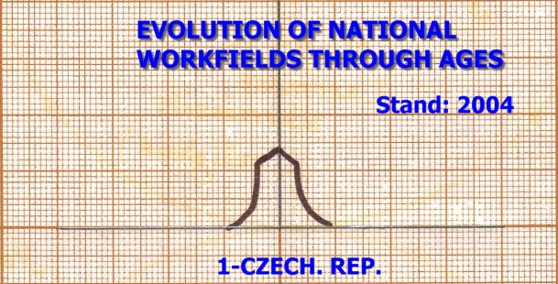  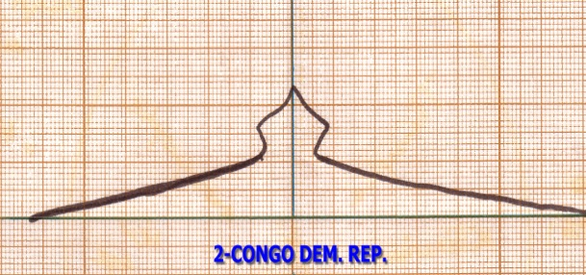  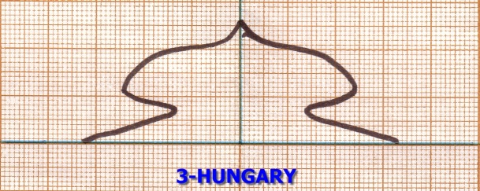  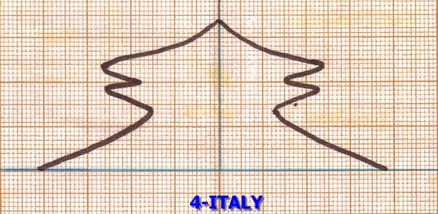  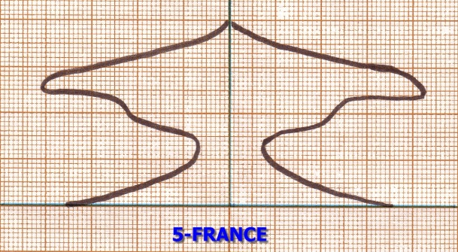 | 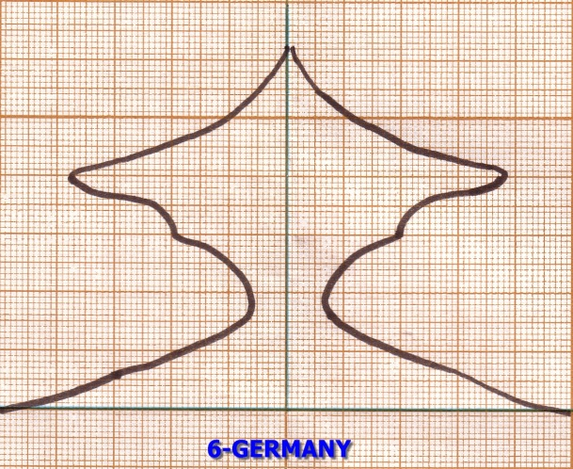  1  2  3  4  5  6  7  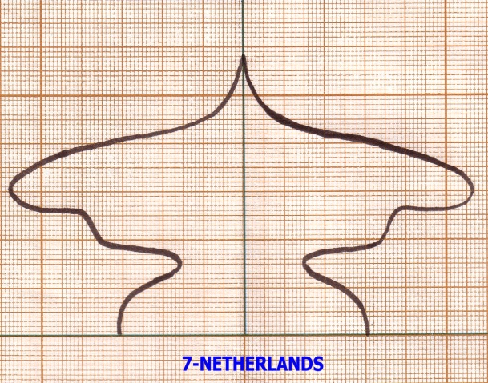  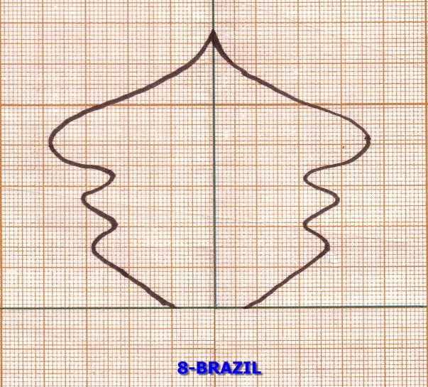
woman
Chart N°8
CHRISTIANITY AND ESOTERICISM COMPARED ACCORDING TO GORDON MELTON

 | Christianity | Esotericism
Relationship to God | Pesonal deity | Impersonal deity
Begin of time | Creation of the world by fiat | Emanation of the world in stages
End of time | Salvation | Enlightenment
Cause of fall | Sin | Ignorance, forgetfullness
Consequence of fall | Incarnation | Entrapped souls
Factor of rise | Devotion | Spiritual disciplines/ exercices
Afterlife | Afterlife in heaven/ hell | Afterlife in new learning situation (reincarnation)
Human state of being | Humans as creatures | Humans as divine sparks
Reality level of evil | Material and evil are real | Material and evil ultimately unreal
Form of worship | Church | School
Diagram N°3

THE REALM OF SHAMBALLAH

THE UNFALLEN MANKIND (OR SIXTH COSMIC DOMAIN)
THE SEVEN RAYS OF THE HOLY SPIRIT

THE VACUUM OF SHAMBALLAH
THE REFLECTION SPHERE

THE MATERIAL SPHERE

THE WORLD OF FALLEN MANKIND
(OR SEVENTH COSMIC DOMAIN)
BIBLIOGRAPHY
Abiven, M., « Les soins palliatifs terminaux », Actualité et Dossier en Santé Publique, N°28, 1999, pp. 18-19.
Agamben, Giorgio, Homo Sacer. Le pouvoir souverain et la vie nue, Paris, Seuil ; coll. « L’ordre philosophique », 1997
Baszanger, I., Douleur et médecine, la fin d’un oubli, Paris, Seuil, Coll. La couleur des idées, 1995
Bauman, Zygmunt, Modernité et Holocauste, Paris, La fabrique éditions, 2002 [1989].
Becker, H., Outsiders, Etudes de sociologie de la déviance, Paris, Médaillé, Coll. Observations, 1985.
Brugidou, M., L’opinion et ses publics, Paris, Presses de Sciences Po, 2008.
Burrin, Philippe, Ressentiment et apocalypse. Essai sur l’antisémitisme nazi, Paris, Seuil, coll. « XXe siècle », 2004
Cadiou, S., Dechezelles, S., « La problématique de l’émergence pour l’étude des mobilisations collectives : Pistes et repères », in Passer à l’action : Les mobilisations émergentes, Paris, L’Haramattan, coll. Logiques Politiques, 2007, pp. 11-48
Castra, Michel, Bien mourir. Sociologie des soins palliatifs, Paris, PUF, 2003.
Castra, Michel, « L’émergence des soins palliatives dans la médecine, une forme particulière de militantisme de fin de vie », Quaderni, N°68, Hiver 2008-2009, pp.25-33
Castra, Michel, « Les équipes mobiles de soins palliatifs, entre expertise et ‘’entreprise morale’’ », Sociologie Santé, N°27, décembre 2007, pp. 115-130.
Denning, Eric, « Norbert Elias, la civilisation et la formation de l’Etat : à propos d’une discussion faisant spécialement référence à l’Allemagne et à l’Holocauste », in Bonny, Yves ; Queiroz, de, Jean-Manuel ; Neveu, Erik (dir.), Norbert Elias et la théorie de la civilisation. Lectures et critiques, Rennes, Presses universitaires de Rennes, coll. « Le sens social », 2003, p. 40-41
Foucault, Michel, Le pouvoir psychiatrique, Cours au Collège de France (1973-1974), Paris, Gallimard-seuil, coll. « Hautes Etudes », 2003.
Foucault, Michel, Naissance de la biopolitique, Cours au Collège de France (1978-1979), Paris, Gallimard-seuil, coll. « Hautes Etudes », 2004.
Foucault, Michel, « Omnes et singulatim » : vers une critique de la raison politique » (1979), in Dits et Ecrits. 1954-1988. IV. 1980-1988, Paris, Gallimard, coll. « Bibliothèque des sciences humaines », 1994.
Foucault, Michel, Sécurité, territoire, population, Cours au Collège de France (1977-1978), Paris, Gallimard-seuil, coll. « Hautes Etudes », 2004.
Glaser, B. ; Strauss, A., Time for dying, Chicago, Aldine Publishing Company, 1968.
Giraud, O., Warin, P. (dir.), “Les politiques publiques: Une pragmatique de la démocratie”, in Politiques publiques et démocratie, La Découverte/ PACTE, pp. 7-31.
Heindel, Max, The Rosicrucian Cosmo-Conception or Mystic Christianity, Rosicrucian Fellowship international headquarters, Oceanside, 1998, I. Part, Chap. III-IV, pp.87-172.
Leibovici, Martine, “Biopolitique et compréhension du totalitarisme. Foucault, Agamben, Arendt », Tumultes, « La fabrication de l’humain. Techniques et politiques de la vie et de la mort », vol. 1, 25, octobre 2005.
Michel, Jörg, « Patientenverfügungen gehören ins Gesetz », Berliner Zeitung online, Textarchiv, 28. 05.2009
Nguyen, V.-K., « Antiretroviral Globalism, Biopolitics and Therapeutic Citizenship », in: Global assemblages – Technology, Politics, and Ethics as Anthropological Problems, Blackwell Publishing, 2005, pp. 124-144.
Noxaïc, Armand, le, Les métamorphoses du vide, Paris, Belin, coll. Pour la science, 2004.
Petri, Catharose de, Transfiguration, Rozekruis Pers, Haarlem, 1980.
Wedemeyer, Inge von (Ed.), Die Goldenen Verse des Pythagoras, Lebensregeln zur Meditation, Verlag Heilbronn, Heilbronn, 1983.
Rijckenborgh, Jan, van, The Gnosis in present-day manifestation, Rozekruis Pers, Haarlem, 1980.
Rijckenborgh, Jan, van, The Mystery of Life and Death, Rozekruis Pers, Haarlem, 1961.
Rijckenborgh, Jan, van, The Call of the Rosycross Brotherhood, Rozekruis Pers, Haarlem.
Rijckenborgh, Jan, van, The Coming New Man, Rozekruis Pers, Haarlem, 1957.
Rijckenborgh, Jan, van, The Brotherhood of Shamballah, Rozekruis Pers, Haarlem, 1953.
Siméant, J., « Friches, hybrides et contrebandes : sur la circulation et la puissance militantes des discours savants » ; in Discours savants, discours militants : mélange des genres, L’Harmattan, 2002, pp. 17-53.
Strauss, A., “Social worlds and their legitimation processes”, in Denzin, N. (Ed.), Studies in symbolic interaction, vol. 4, Greenwich/ London, JAI Press INC, 1982, pp. 171-190; And vol. 5, Greenwich/ London, JAI Press INC, 1984, pp. 123-139.
Strauss, A., La trame de la négociation – Sociologie qualitative et interactionnisme, Paris, L’Harmattan, 1992.
Taïeb, Emmanuel, « Du biopouvoir au thanatopouvoir, Quaderni, N°62, Hiver 2006-2007, pp.5-15.
Taïeb, Emmanuel, « Pouvoir et individuation. Une lecture de Foucault et d’Elias », Labyrinthe, « La biopolitique (d’) après Michel Foucault », 22, 2005.
Tournay, V., « Ce que revendiquer veut dire. Eléments pour une pragmatique de la monstration », Quaderni, 68, Hiver 2008-2009, p. 5-11.
Tournay, V., « Comment inscrire durablement les revendications militantes, les pratiques sociales et les récits historiques ? », in Tournay, V. (dir.), La gouvernance des innovations médicales, Paris, PUF, 2007.
Winck, D. ; Weisz, G., « Les mutations de l’action publique sanitaire. Quelle histoire et quelle place donner aux régimes de production des connaissances ? », in Tournay, V. (dir.), La gouvernance des innovations médicales, Paris, PUF, 2007.

SITOGRAPHY
On-going resources: This page is an ongoing list of websites featuring articles or documents we use to conduct our research.

- Association pour le Droit de Mourir dans la Dignité (ADMD) :
http://www.admd.net/
- Circulaire N°DHOS/G/2005/57 du 2 février 2005 relative à la laïcité dans les établissements de santé :
http://www.sante.gouv.fr/adm/dagpb/bo/2005/05-02/a0020035.htm
- Euthanasia and Assisted Suicide: International Experiences. Online Publication of the Canadian Parliamentary Information and Research Service:
http://www.parl.gc.ca/information/library/PRBpubs/prb0703-e.htm
- Golden Verses of Pythagoras:
http://www.sacred-texts.com/cla/gvp/gvp03.htm
-Homepage of the Rosicrucian Fellowship on the Internet :
http://www.rosicrucian.com
- Homepage of the Golden Rosycross on the Internet:
http://www.lectoriumrosicrucianum.org/english/index.htm
- L'exercice médical face au multiculturalisme, dossier n°8 d’octobre 2005 du conseil national des médecins :
http://bulletin.conseil-national.medecin.fr/Archives/html/509/509BOMN509P08A1.htm
- Loi n°2005-370 du 22 avril 2005 relative aux droits des malades et à la fin de vie, NOR: SANX0407815L, Version initiale (consolidée au 23 avril 2005) :
http://www.legifrance.gouv.fr/affichTexte.do?cidTexte=JORFTEXT000000446240&dateTexte=
- Loi n°2005-370 du 22 avril 2005 relative aux droits des malades et à la fin de vie, NOR: SANX0407815L, Version en vigueur au 4 juin 2009 :
http://www.legifrance.gouv.fr/affichTexte.do;jsessionid=718ABDBE19E78BDF1CCB402247FF894D.tpdjo02v_2?cidTexte=LEGITEXT000006051560&dateTexte=20090604
- Official Website of Jehovah’s Witnesses in France:
http://www.temoinsdejehovah.org/
- Nicolas Sarkozy and religion :
http://www.lexpress.fr/actualite/politique/nicolas-sarkozy-et-la-religion_469378.html

